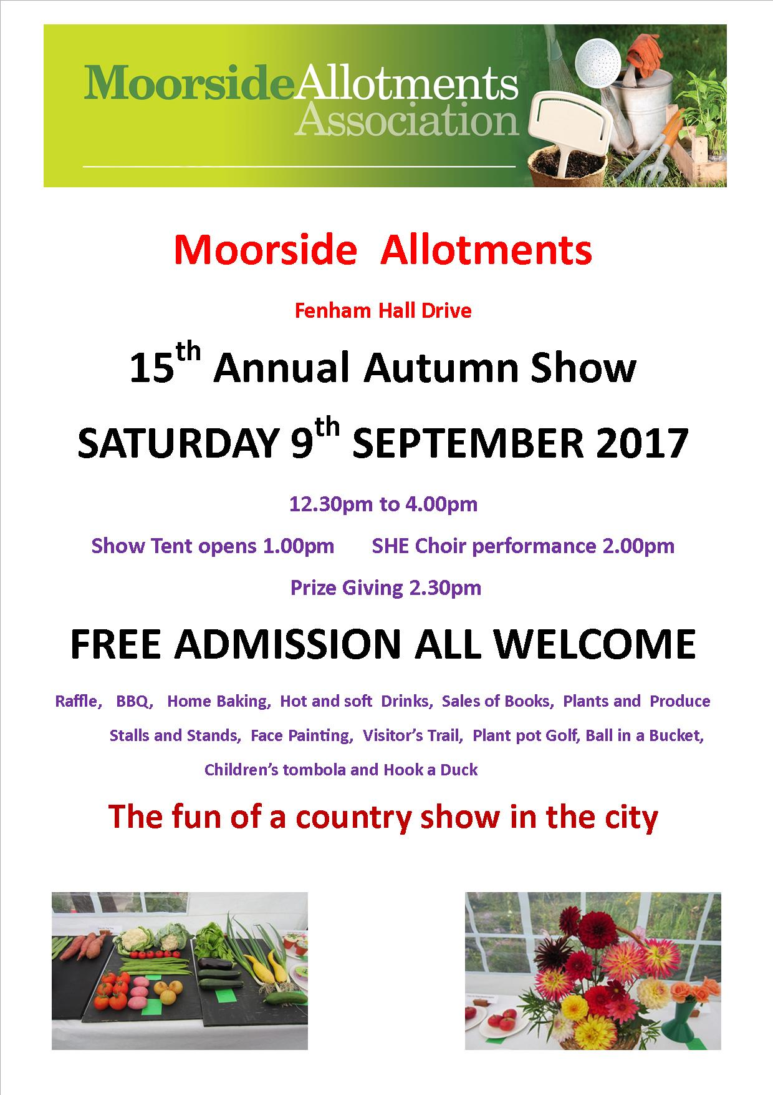
Please use the entry form if you wish to enter any of the categories at the show.
Show Rules
1. Classes are open to all members of the Moorside Allotments Association. Life honorary members are also eligible to enter.

2. All entries will be the bona fide work of the exhibitor, grown at Moorside Allotments or where the exhibitor resides.

3. The judges' decision is final.

4. Only one entry per class allowed.

5. Entries to be with the Show Secretary on completed entry forms by 2.00pm Friday 8th of September.

Completed forms should be sent to:
The Show Secretary at

The red post box at the centre gate

Or: The Trading Hut during normal opening hours
10.00am to 12 noon Saturday and Sunday

Or: On Friday 8th September 1.00pm to 2.00pm
at the Trading Hut

All Entries must be received by the Show Secretary no later than 2.00pm Friday 8th September.

No Entries allowed on Show Day

The Show Schedule for Saturday 9th September is as follows:

9.00am Exhibit cards, flower vases, paper plates, exhibit trays and sand will be available in the trading hut area.

9.30am to 11.00am Staging of exhibits. All exhibits must be on the show benches by 11.00am.
Only those actually placing their items or a supporter placing exhibits on behalf of another (or with the exhibitor if a child for example) will be allowed in the tent during staging.

11.15am Judging by Nick Ghost and Terry Maxwell, ex-chairpersons of Fenham Model and Moorside Allotments Associations.

12.30pm Gates open to the public

1.00pm Show Tent open for general viewing of the exhibits.

2.00pm SHE Choir performance

2.30pm Prize giving and Presentations. Followed immediately by raffle draw

4.20pm Entrants should collect any of their exhibits that they want to keep. Unwanted exhibits will be placed on the exchange bench. Flowers will be retained until Sunday for sale at the Trading Hut or given as thanks to contributors.

SHOW CATEGORIES
Section One: Vegetables
1. Potatoes (5)
2. Carrots (3)
3. Beetroot (3)
4. Onions (3)
5. Shallots (6)
6. Runner beans (6 pods)
7. Broad beans (6 pods)
8. Fine Beans (French/Borlotti) (6 pods)
9. Pot leek (2)
10. Blanched leek (2)
11. Cucumber (1)
12. Tomatoes (6)
13. Cabbage (1)
14. Cauliflower (1)
15. Parsnips (3)
16. Peas (6 pods)
17. Turnips (2)
18 Swede (1)
19. Sweet-corn (2)
20. Pepper, sweet (1)
21. Peppers, chilli (3)
22. Garlic (3)
23. Aubergine (1)
24. Courgettes (3)
25. Rhubarb (3 sticks)
26. Any other Vegetable

Section Two: Flowers
27. Gladioli (3)
28. Sweet Peas (6 stems)
29. Chrysanthemum any class (3)
30. Pompom / Ball Dahlia (3)
31. Cactus Dahlia (3)
32. Decorative Dahlia (3)
33. Collerette / Waterlily Dahlia (3)
34. Roses (3 or 3 stems if cluster-flowered)
35. Any other flower (3 or three stems if cluster flowered)
36. Basket of Flowers

SHOW CATEGORIES

Section Three: Fruit
37. Plate Dessert Apples (3)
38. Plate Cooking Apples (3)
39. Plate Pears (3)
40. Plate Plums (3)
41 Plate soft fruit

Section Four: Home Produce
42. Jar of jelly
43. Jar of jam
44. Jar of marmalade
45. Jar of chutney
46. Jar of pickle
47. A decorated cake
48. Cup cakes (3)

Section Five: For Children

Under sevens:
49. Drawing of a fruit, veg or flower
50. Funny face using fruit, veg, flowers or a mix
51. Monster made of fruit, veg, flowers or a mix
Seven to Fourteen:
52. Drawing of a garden or allotment
53. Scarecrow (two feet max size)
54. Monster made of fruit, veg or flowers or a mix

Section Six: For Fun
55. Ugliest vegetable
56. Smallest carrot
57. Longest runner bean
58. Largest onion
59. A decorated egg

SHOW CATEGORIES
Section Seven: Photograph
60. Best photograph taken on Moorside Allotments.
No bigger than 7” x 5” printed. Colour or Black and White.
One entry per person only.

Section Eight: Bowls and Trays
61. Salad Bowl Any three kinds of salad from:-
Lettuce (1); radish (2); courgettes (2); salad onions (3); cucumber (1); salad potatoes (3); tomatoes (3); Any other salad vegetable (number as listed in section one)

62. Top Tray
Three types of vegetable from this list:-
3 carrots; 2 cauliflowers; 3 onions; 3 parsnips;
6 pea pods; 3 potatoes; 6 runner bean pods;
6 tomatoes or any vegetable in section one (number as listed)

63. Top Vase
Mixed flowering stems containing a total of between 5 and 10 stems taken from 2 or more different kinds of plant

Section Nine: Trophies and Awards
64. Junior Master Gardener
Two different vegetables grown by a junior under the age of 14

Further awards are made on merit at the time of the show including

Moorside Champion Gardener The most points in the Show

Top Vegetable Gardener The most points for vegetables

Best Exhibit in Show

Prize card awards are awarded for the outstanding entries
in the following categories:
Best for fun - chosen from best in categories 55-59
Best Dahlia - chosen from best in categories 30-33
Entry Form
Moorside Allotments Association 15th Autumn Flower and
Vegetable Show Saturday 9th September 2017
Entry Forms To Be Submitted By 2.00pm Friday 8th of
September 2017. No Entries Can Be Accepted on Show Day
Class Class
No. Description of class No. Description of class
 | Examples......
1 | Potatoes | 27 | Gladioli
cut sheet to send in please Additional forms are available at the trading hut and in the notice board adjacent to the trading hut. PTO
Cut form to send in please

The class number is listed against the show category that you wish to enter. Giving a description of the category will reduce the likelihood of mistakes.

The judges like to see the name of the variety or cultivar you are exhibiting. There is a space for you to fill this in on the exhibit card that you will be given. If you are unsure of the variety or have forgotten, please state “unknown”. The exhibit card must be placed on the show bench with your produce. The side with your name should be face down; it will be turned over for viewing if you win a prize.

Judging on the day will be by Nick Ghost and Terry Maxwell

Member’s Name: ………………………..………………………………

Plot No: …………………………………………………..……

No. of Entries ………………………………………………….….....

Please ensure that this form is handed in by
2.00pm Friday 8th September 2017

The entry brochure is available on the Moorside Allotment Website

